

ONLINE PAYSLIPS

USER GUIDE

Prepared by G Griffiths  
March 2013

**Background**

Welcome to the GDI Online Payslips training manual. The company is embarking on a process of eliminating the need to send paper based payslips. There are significant advantages to this, including:

* Significant reduction in printing costs
* Significant reduction in environmental impact due to less paper used
* Reduction in payroll processing time
* Enabling employees to have access to a ‘self-service portal’
* Complete history of advice slips that can be reprinted many times by employees
* Reduction in the workload of Payroll Clerks in not having to mail advice slips individually, or answer queries regarding reprinting payslips

This is setup using a web based system call Penny. There are many advantages to this:

* Will work on almost any machine
* Can be accessed anywhere
* Easy to setup
* No computer installation needed
* Can be printed multiple times

**Implementation**

We are currently in the testing phase. Starting in May 2013, all payslips for employees will be published online as well as distributed by paper as usual. This parallel process will continue for 6 months. After this period, Payroll will no longer issue paper based payslips.

**Instructions on how to use Penny**

As mentioned above, Penny is a web based system. It is tested to work on all main browsers (Internet Explorer, Firefox, Safari, Google Chrome). Instructions in its operation follow in these main categories:

* Sign in
* Transactions
* Reports
* Inquiry
* Help
* Logout

**Sign in**

In order to help in the login process, we have designed a front end web page. This can be accessed at http://services.gdins.org. Going to this page will display the following section (only top part shown)

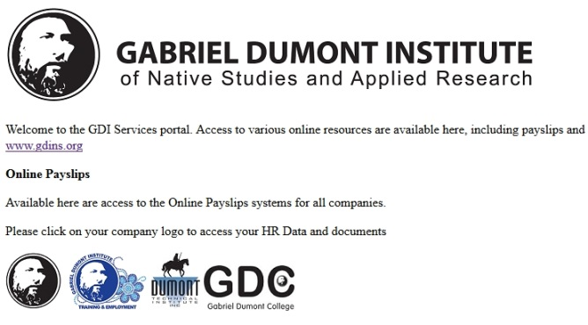

As we have 4 companies that have a payroll need, there are actually 4 websites setup. Click on the company logo for the organisation you belong to. If you select the wrong one, press the back button.

You will then be presented with a Logon screen, looking like this:

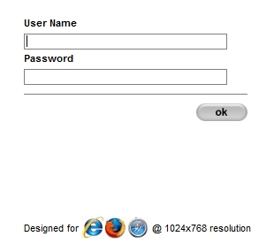

Enter your employee ID from your payslip and the password and press OK

*N.B. initially your password will be set to your Social Insurance Number. Use Change Password to change it to something memorable.*

After successful login, a screen with your name at the top is listed, and the menus Transactions, inquiry and reports is displayed

**Transactions**

The transactions menu will give you access to 2 items, Welcome (which takes you back to the home screen) and change password.

Change Password

* Clicking on Change Password brings up the following:

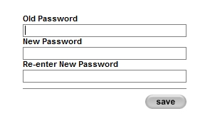

Change your password as follows:

* In the Old Password field, enter your current password
* In New password field, enter the password you would like to change it to
* In “Re-enter New Password”, enter the password you want to change it to again
* Press save. As long as the 2 new passwords match, the system will save the new password
  + *If the password is forgotten, it cannot be discovered, but can be changed by IT or Payroll by emailing* [*support@gdins.org*](mailto:support@gdins.org)

**Printing Reports**

There are 3 types of document available through the system to print. These are:

* Advice Slips (Payslips)
* Expense Slips
* T4

Let us look at each in turn.

**Advice Slips**

This is the main function for this system. It will allow you to print any pay slip that has been issued to you during your employment. To access this, do as follows:

* Go to Reports-Advice Slip
* A list of all advice slips is displayed showing the Pay period, net pay and batch name
* Double click on the one you want to see. This will open in a new window/tab
* This can be printed using the Print icon
* To look at another one, close the tab/window and go back to the one titled Advice Slip

**Expense Slip**

The system will also let you browse and print the Expense claims paid to you. Access this as follows:

* Go to Reports-Expense Slips
* A List of expense claims is displayed showing Date, Voucher No and amount.
* Double click on the one you want to see. This will open in a new window/tab
* This can be printed using the Print icon
* To look at another one, close the tab/window and go back to the one titled Advice Slip

**Printing T4**

After the Payroll Year ends and the T4 processing is done, your T4 slip will be available for you to print yourself. This is accessed as follows:

* Go to Reports-employee T4
* This will display the current T4
* will allow you to scroll through each T4 on record(2012 will only have 1 record, so this will work from 2013)
* will show the earliest T4 record on file
* will show the latest T4 Record on file
* Printable version – will format the report exactly as the T4 looks
* After selecting Printable version, press the  Print icon to print

**Other Functions**

**Inquiry**

Also available to you is a facility to look at your Payroll data that is held in Great Plains. This only allows you to view and not to change this information.

* To access this, go to inquiry-employee setup
* This takes you to the Employee Card, showing your address and other information that Great Plains has stored
* From here there are 4 buttons giving extra information (These are also accessible from the top drop down menu). This gives you access to the following information:
  + TD1 values – Tax Credit and Payroll setup information
  + Deposit – Bank account details stored in the system
  + Calculated – breakdown of the payroll calculations from Great Plains
  + T4 – Running Total of the current years deductions and benefits as they will appear

**Help**

Throughout the system is a help system that is context sensitive – i.e. relates to the page you are currently on. This is accessed from the Help link in the top right of the screen

**Logout**

After you are finished, it is always a good practice to logout of the system. This clears any saved cookies, and removes your login from the system.

This is essential if you access this from a public or shared machine in order to protect your own personal information.

* *Please note that clicking the company logo at the top of the screen will return you to the logon screen, but will not log you out. Pressing back will take you to the previous screen with all information accessible, leaving you at risk*