

IT DEPARTMENT

MANAGEMENT REPORTER USER GUIDE

Gareth Griffiths
December 2013
v1.0

Introduction

Great Plains is the accounting system used by the Institute. As part of this a report writer called Management Reporter is available. This allows financial reports to be written that can assist Program Coordinators to manage their financial information.

Management Reporter runs on the Great Plains Server and is available from any of our locations on the secure VPN network. Through the use of a separate VPN client, this will also be available from outside of the GDI Networks

Management Reporter allows access to financial information, even down to transaction level through a process called Drill-Down. This is where clicking on a category will show the next level of information.

Process of producing reports

Information is entered into Great Plains as it is received. At month end, certain procedures need to be completed by Finance.

The process for producing Management Reporter Reports will be as follows:

- By the 20th day of the next month, as many transactions as possible will be entered and posted for the prior period.
- All payables, receivables and bank balances will be reconciled
- A provisional set of reports will be issuedon or around the 20th day. These are not confirmed, and are liable to change. An email will be sent to let Program Coordinators know these are published. These figures can be used to identify and report any errors in the system.
- The Coordinators will have 5 days to query any errors or omissions
- Once these checks are completed, a final set of reports will be issued for that month on or around the 25th day of the month. These figures may still change but will present the best information available at that time. An email will be sent to Coordinators when this is done
- Any errors or omissions identified after this date will be reflected in the following month’s reports
- Each month will be stored separately in a new folder, so reports will be available historically as well.

Security

Management Reporter has a full security module that enables you to only see the information you are authorized to see.

This means you will only see the departments you are responsible for. Security is controlled by user names on the domain

Please note the passwords are case sensitive. If the password or user name is forgotten, please contact IT at support@gdins.org to get this reset.

Accessing Management Reporter

To access Management Reporter, click on the Management Reporter icon. This will launch a Remote Desktop session

The following screen is displayed:

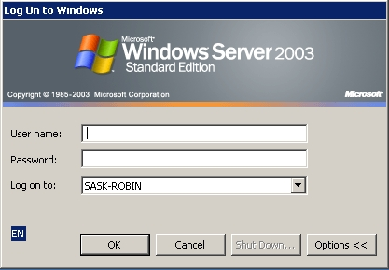

- Type the username and password provided in the relevant boxes (remember it is case sensitive). If you are based in Head Office, this will be the domain logon you use every day, otherwise it will be provided to you.
- Press OK

The following window is displayed:

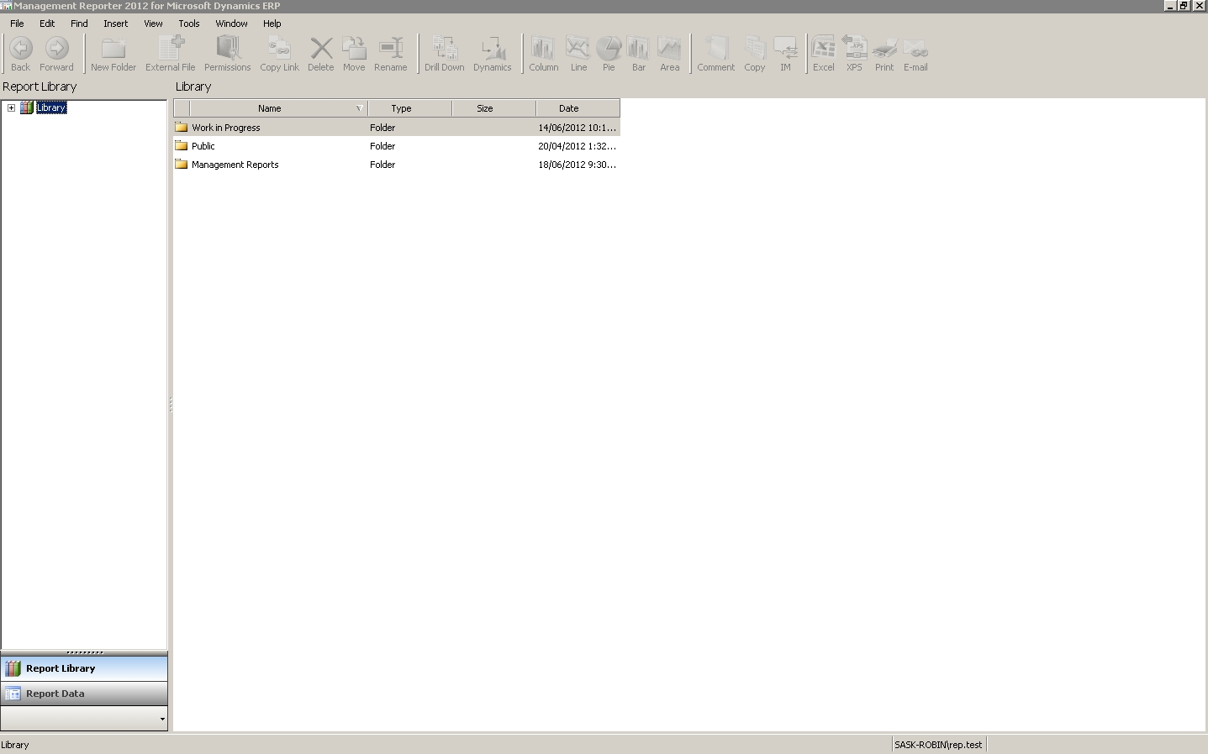

Using the Report Library

The Report Library is a list of available reports. To access the reports, click on the plus signs next to the top level menus. For example, to look at the DTI Management reports for January 2013, expand Management Report (Press Plus sign), expand DTI, expand 2012-13, then Expand 07-January. The following will be displayed with the available reports for that month in the middle of the window

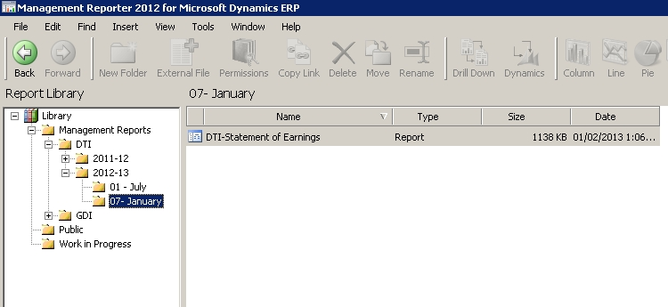

To access any report in the list, double click on the report in the middle of the window. As long as you have access to this report, it will load.

To go to another report, press the Report Library tab at the bottom of the screen (you can also select from the menus using View-Report Library, or press Ctrl-1)

To return to the previously opened report, press Report Data at the bottom of the screen (or from menus select View-Report Data or or press Ctrl-2)

Once you are finished with using Management Reporter, press the Exit button in the top right hand corner. This will log you out automatically as well as closing the application

Using the Reports

Once you open a report description the following window is displayed:

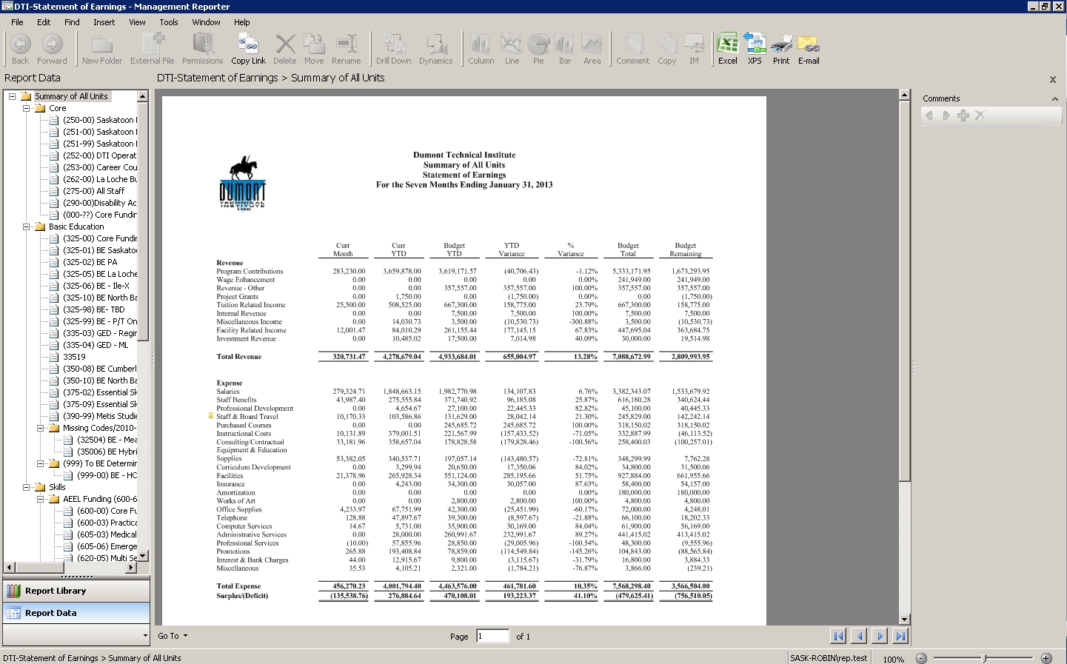
Financial columns

Reporting Units
Account Rows (Drill Down where available)
Comments Pane

The Departments are listed on the left. Once again, depending upon your access rights, you may be able to select different departments here.

Clicking on each level of the tree will display the report for that department only. Expanding the tree and clicking on a subdepartment will display the whole report for that sub-department, i.e. Saskatoon CRF Regular

To see further breakdowns on the report (Drill Down), double click on the account row in the middle of the screen. This will drill down to the next level of the organizational tree. Depending upon the report drill down is available right down to transaction level.

However please note that drill down to a transaction will only work on Current Month balances. If there is no amount in the Curr Month column, it will not show any transactions for that row

To go back to a previous level, press the Back button in the top toolbar

Printing Reports

To print, press Print on the toolbar. The following window will open:

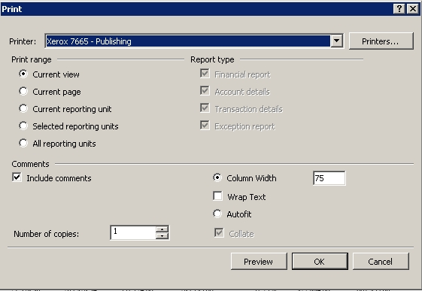

Let us look at the options:

- Printer – Select your printer
- Under Print Range, select one of the following options.
  - Current View - The current view displayed. This would include multiple pages if the view is longer than one page
  - Current Page - The page that is currently displayed in Report Viewer.
  - Current Reporting Unit – Prints the report for the department highlighted
  - Selected reporting units – Opens a dialog box where you can select the reporting units to print
  - All reporting units – All reporting units in a reporting tree (could be a long report due to the number of departments, use with caution)
- Report Type: If one of the Reporting Unit print ranges are chosen, this lets you select whether the report you want is a financial (Summary) or detail. If detail is selected, it gives you the option to select account detail and/or transaction detail is required. (in most cases, a Financial Report is all that is required)
- Comments – Select whether to print comments or not
- The page scaling can be controlled through either a column width, or by selecting Autofit

Pressing Ok will cause the report to be printed, or it can be checked using Print Preview

Note: if the printer you have is not listed, you may need to get IT to add this printer driver to the server. Please email support@gdins.org to request this

Comments

It is possible to record comments against a report row as a reminder for others and yourselves to check something.

Any comments added are stored against the username and displayed in the Comments pane on the right hand side.

To add a comment, do the following:

- Highlight the row to comment on.
- The Comment button in the toolbar will become active.
- Press this button, and a new text window is displayed
- Add the comment you want to save and press OK
- This will now be displayed as a little yellow sticky note, and displayed in the the right hand comments pane when that row is highlighted (it will also display if you hover over the sticky note)

To remove a comment:
- Click on the comment in the right hand panel
- Press the red ‘X’ to delete
- Confirm deletion, and the comment is removed
- Please note, you can only remove your own comments from a document unless you are an administrator

Graphs

It is also possible to create a graph of any row or column of data. This graph can be a Column, Line, Pie, Bar or Area graph.

To create a graph, do the following:
- On any figure in the column you want, press the right hand mouse button.
- Choose Select Column (or row)
- The charting tools become active above
- Select the chart type and the chart is created (Pie works best)
- The following is displayed after creating the chart

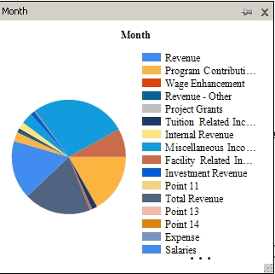

Modifying the Chart
- Pressing the right hand mouse button over the chart gives you different options:
  - Copy- Copy to clipboard for inserting into Excel
  - Show Legend – Toggle labels on and off
  - Chart Type – Quickly change type of chart
  - Palette – Change colours used quickly
  - Series – display or hide different rows from the graph
  - 3D – Show a 3D chart
  - Chart Title – Change the heading of the chart or delete the title
- So, with some quick modifications, the chart above can be updated to look like this:

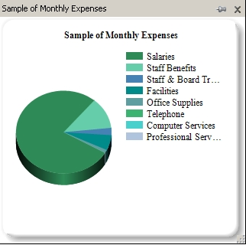

Docking the Chart
- You can pin the chart to the comments section by pressing the map pin in the header of the chart window.
- This then moves the chart to the right hand side under the comments
- To undock this, press the Configure (lightning bolt) icon, and choose Undock

Removing the Chart
- There are 2 ways to delete a chart depending on if it is docked or not
  - If docked, press configure (lightning bolt), press Close and confirm deletion
  - If undocked, press the x in the top right of the chart window

Export to Excel

The data can be sent to Excel for viewing and analyzing outside of this. To do this:

- Click on the Excel button in the toolbar
- The following dialog is displayed: (similar to the print icon)

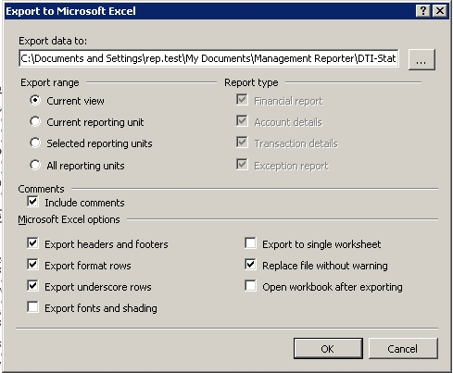

- In the network path, due to the way Management Reporter is configured through Terminal Server, the default path will be a location you will not have access to after closing the connection. To access your local computer, choose the following path:
  - Browse to My Computer using the Browse button […]
  - Select (your computer name will be different)
    - If you have a network connection or USB drive, you can select a different drive letter, e.g. H: for your Home Directory)
  - Select a path
  - This will then allow you to save it to your local disk
- Enter a filename and press Save
- Decide upon the amount of detail you want (Current Reporting Unit is usually OK)
- You can usually leave the rest of the options as they are and press OK
- This will now export information to Excel and save it on your hard disk
Logging out

In order to release a license for someone else to use, it is important to logout properly from the system. This will immediately release the license without having to wait for the session timeout limit to be reached

- To do this, press the X in the top right hand corner to exit the program. This will both close the Management Report Viewer and log you out.

N.B. you may notice an X in the middle of the screen pop down when hovering over the top of the screen, alongside the IP address 192.168.100.4. This does not perform the same function. This will cause the session to be suspended, but not closed or logged out.

It can cause issues if users are not logged out correctly in updating, or running system processes. It also creates system resource overhead, as the server has to retain the state of these paused connections.. It is always better to use the Exit function in the top right corner

